**Shampoo Packaging Line:**

**What is Packaging?**

Packaging is the technology of enclosing or protecting products for distribution, storage, sale, and use. Packaging also refers to the process of design, evaluation, and production of packages. Packaging can be described as a coordinated system of preparing goods for transport, warehousing, logistics, sale, and end use. Packaging contains, protects, preserves, transports, informs, and sells.

**Packaging types**

Packaging may be looked at as being of several different types. For example a **transport package** or **distribution package** can be the [shipping container](https://en.wikipedia.org/wiki/Shipping_container) used to ship, store, and handle the product or inner packages. Some identify a **consumer package** as one which is directed toward a consumer or household.

Packaging may be described in relation to the type of product being packaged: [medical device](https://en.wikipedia.org/wiki/Medical_device) packaging, bulk [chemical](https://en.wikipedia.org/wiki/Chemical_substance) packaging,[over-the-counter drug](https://en.wikipedia.org/wiki/Over-the-counter_drug) packaging, retail [food](https://en.wikipedia.org/wiki/Food) packaging, military [materiel](https://en.wikipedia.org/wiki/Materiel) packaging, [pharmaceutical](https://en.wikipedia.org/wiki/Medication) packaging, etc.

It is sometimes convenient to categorize packages by layer or function: "primary", "secondary", etc.

* Primary packaging is the material that first envelops the product and holds it. This usually is the smallest unit of distribution or use and is the package which is in direct contact with the contents.
* Secondary packaging is outside the primary packaging, perhaps used to group primary packages together.
* Tertiary packaging is used for [bulk handling](https://en.wikipedia.org/wiki/Logistics), [warehouse](https://en.wikipedia.org/wiki/Warehouse) storage and [transport](https://en.wikipedia.org/wiki/Transport) shipping. The most common form is a [palletized](https://en.wikipedia.org/wiki/Pallet) [unit load](https://en.wikipedia.org/wiki/Unit_load) that packs tightly into [containers](https://en.wikipedia.org/wiki/Containerization).

These broad categories can be somewhat arbitrary. For example, depending on the use, a [shrink wrap](https://en.wikipedia.org/wiki/Shrink_wrap) can be primary packaging when applied directly to the product, secondary packaging when combining smaller packages, and tertiary packaging on some distribution packs.

**Shampoo Packaging:**

Shampoos are cleaning formulations used for a wide range of applications, including personal care, pet use, and carpets. Most are manufactured in roughly the same manner. They are composed primarily of chemicals called surfactants that have the special ability to surround oily materials on surfaces and allow them to be rinsed away by water. Most commonly, shampoos are used for personal care, especially for washing the hair.  
  
**Manufacturing Process:**

After a shampoo formula is developed, it is tested to ensure that its qualities will minimally change over time. This type of testing, called stability testing, is primarily used to detect physical changes in such things as color, odor, and thickness.

It can also provide information about other changes, like microbial contamination and performance differences. This testing is done to ensure that the bottle of shampoo that is on the store shelves will perform just like the bottle created in the laboratory.

The manufacturing process can be broken down into two steps. First a large batch of shampoo is made, and then the batch is packaged in individual bottles.  
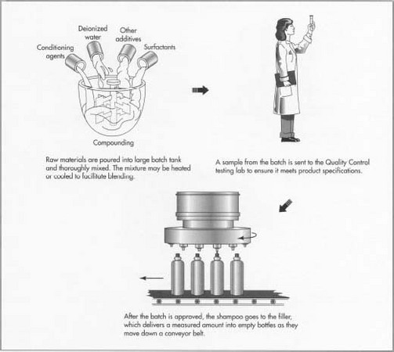

**Compounding:**

Large batches of shampoo are made in a designated area of the manufacturing plant. Here workers, known as compounders, follow the formula instructions to make batches that can be 3,000 gal (11,000 1) or more. Raw materials, which are typically provided in drums as large as 55 gal (200 1) or in 50-lb (23-kg) bags, are delivered to the compounding area via forklift trucks. They are poured into the batch tank and thoroughly mixed.

Depending on the formula, these batches can be heated and cooled as necessary to help the raw materials combine more quickly. Some raw materials such as water or the primary detergents are pumped and metered directly into the batch tank.

These materials are added simply by pressing a button on computerized controls. These controls also regulate the mixing speeds and the heating and cooling rates. Depending on the size and type of shampoo, making a 3,000-gal (11,000-1) batch can take anywhere from one to four hours.

**Quality control check:**

After all the ingredients are added to the batch, a sample is taken to the Quality Control (QC) lab for testing. Physical characteristics are checked to make sure the batch adheres to the specifications outlined in the formula instructions. The QC group runs tests such as pH determination, viscosity checks, and appearance and odor evaluations. They can also check the amount of detergent that is in the formula and whether there is enough preservative. If the batch is found to be "out of spec," adjustments can be made. For instance, acids or bases can be added to adjust the pH, or salt can be added to modify the viscosity. Colors can also be adjusted by adding more dye.

After a batch is approved by QC, it is pumped out of the main batch tank into a holding tank where it can be stored until the filling lines are ready. From the holding tank it gets pumped into the filler, which is made up of a [carousel](http://www.madehow.com/knowledge/Carousel.html) of piston filling heads.

**Packaging Line:**





The Shampoo Packaging (Bottling) line consists of following machines:

1. **Filler:** Fillers (or filling machines) are used for packaging, mainly for food/beverage but for other products as well. These are used to fill either a bottle or a pouch, depending on the product:

There are several types of fillers used by the packaging industry. The following are the most common:

* **Auger/agitator filling machines**: designed to fill dry mixes, such as flour and sugar. The fillers have a hopper shaped like a cone that holds the mix and puts it in a pouch using an auger screw that is controlled by the agitator. The mix is filled in a pouch that is made of paper or poly that is formed in a collar and the pouch gets sealed by a series of heaters and dies.
* **Flow filling machines**: designed for liquids, oils, and thin food products. These fillers are designed when they fill a bottle or tub that enters the machine, the ejects the open bottle back onto another conveyor for sealing.
* **Tablet fillers**: These are designed for products that are counted by pieces instead of weight. These are designed for small bottles (similar to some of the flow fillers), but the hopper of the filler is set up to permit scan counting of tablets or candy pieces.
* **Positive displacement pump fillers**: positive displacement, pump filling machines easily handle a wide range of container sizes, fill volumes and product types. While originally designed for filling creams, gels and lotions these fillers also handle water thin and heavy paste products. Some of the products this machine easily fills are cosmetic creams, heavy sauces, thick shampoo and hair conditioners, honey, hair gels, paste cleaners, and car wax. With simple tool-less cleaning and our PLC control system, product changeover is fast and easy making these our most versatile fillers.
* Vertical form fill sealing (VFFS) machine

Typical Specification for Filling Machine

1. Machine Speed: Bottle/Min (bpm)

2. Filling Accuracy: This parameter of the machine defines resolution of filling in percentage e.g ± 0.5 %

3. No of Heads/Nozzles

4. Range: Product Variants on the filling machine

5. Film Draw Mechanism:

6. Compressed Air: This parameter defines Air pressure required for machine operation

7. Power Consumption: Power required running the machine

8. Dimension and Weight

1. **Capper:** A Capper is a device used to seal bottle caps during the bottling/packing process. The cap is placed on the bottle and both handles are pulled to tighten and lock it.
   1. Typical Specification for Capping Machine
      1. Machine Speed/Capacity
      2. No of Heads/Nozzles
      3. Bottle Size – Diameter & Height of the bottle to be capped
      4. Cap Size
      5. Compressed Air
      6. Power Consumption
      7. Dimension and Weight
2. **Labeller:** A labeller or label printer is a computer printer that prints on self-adhesive label material and/or card-stock (tags). A label printer with built-in keyboard and display for stand-alone use (not connected to a separate computer) is often called a label maker. Label printers are different from ordinary printers because they need to have special feed mechanisms to handle rolled stock, or tear sheet (fanfold) stock. Common connectivity for label printers include RS-232 serial, Universal Serial Bus (USB), parallel, Ethernet and various kinds of wireless.
   1. Typical Specification for Bottle Labeling Machine
      1. Machine Speed (Output/Hr)
      2. Direction of Movement: This defines the movement of labeller is right or left
      3. Height of Conveyor:
      4. Label – Length, Width, Thickness:
      5. Container Size
      6. Wet glue
      7. Driving Mode:
      8. Label Type – Self Adhesive, Transparent, Opaque
      9. Compressed Air
      10. Power Consumption
      11. Dimension and Weight
3. **Cartoner:** A cartoning machine or cartoner, is a packaging machine that forms cartons: erect, close, folded, side seamed and sealed cartons. Packaging machines which form a carton board blank into a carton filled with a product or bag of products or numbers of products say into single carton, after the filling, the machine engages its tabs / slots to apply adhesive and close both the ends of carton completely sealing the carton.
   1. Typical Specification for Cartoning Machine
      1. Machine Speed
      2. Folded Space
      3. Compressed Air
      4. Power Consumption
      5. Dimension and Weight
4. **Palletizer:**  A palletizer or palletiser is a machine which provides automatic means for stacking cases of goods or products onto a pallet. Manually placing boxes on pallets can be time consuming and expensive; it can also put unusual stress on workers
   1. Typical Specification for Capping Machine
      1. Machine Speed
      2. No of Axes:
      3. Reach
      4. Max Palletizing Height
      5. Capacity: This defines capacity of the palletizer to handle the load
      6. Position Accuracy:
      7. Compressed Air
      8. Power Consumption
      9. Dimension and Weight
5. **Conveyor:** A conveyor system is a common piece of mechanical handling equipment that moves materials from one location to another.Conveyors are especially useful in applications involving the transportation of heavy or bulky materials.

The shampoo packaging process has series of steps before it is packed and shipped to warehouse for distribution. The process is explained as follows:

At the start of the packaging line, empty bottles are put in a large bin called a hopper. Here, the bottles are physically manipulated until they are correctly oriented and standing upright. They are then moved along a conveyor belt to the filling carousel, which holds the shampoo.

The filling carousel is made up of a series of piston filling heads that are calibrated to deliver exactly the correct amount of shampoo into the bottles. As the bottles move through this section of the filling line, they are filled with shampoo.

From here the bottles move to the capping machine. Much like the bin that holds the empty bottles, the caps are also put in a hopper and then correctly aligned. As the bottles move by the caps are put on and twisted tight.

After the caps are put on, the bottles move to the labeling machines (if necessary). Depending on the type of labels, they can either be stuck on using adhesives or heat pressed. Labels are stuck to the bottles as they pass by.

From the labeling area, the bottles move to the [boxing](http://www.madehow.com/knowledge/Boxing.html) area, where they are put into boxes, typically a dozen at a time. These boxes are then stacked onto pallets and hauled away in large trucks to distributors. Production lines like this can move at speeds of about 200 bottles a minute or more.

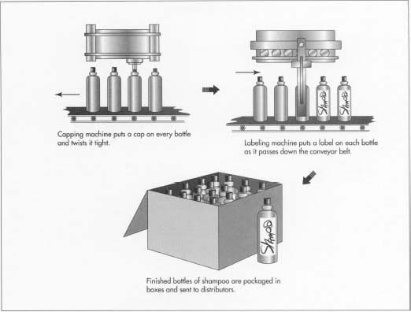

Shampoo Line Flow Chart:

**A**

Initialization & Synchronization

Fill the Hopper

Is Cap Present?

Is Bottle Present?

Lift down the ‘Cap Screw’ and Fasten caps

Place the Cap on bottles

Is Bottle Present?

Wait

Fill the Bottles

Alarm

Wait

Label It

Are Bottles Present?

Erect, Close & Fold Cartons

Place the bottles on the carton & Seal it

Are all cartons ready?

Palletize

**A**

**Packaging Flow:**

The flow chart shown above represents the packaging flow of shampoo bottling line.

When the shampoo line is “Started”, the entire line shall be initialized and synchronized (all packaging machines) for the packaging operation. The shampoo prepared in the processing batch shall be pumped automatically into the filler’s hopper by a pump. The empty bottles shall be placed onto the conveyor either manually or by a pick & place robot. The packing line shall be started by pressing the “Line Start” button on the Line HMI or from remote controlled SCADA screen. Once the “Line Start” all the machines shall be started and automatic packaging process shall start. The conveyor start moving and bottles reach the filling machine. When the proximity sensor ‘detects’ bottle passing at the filling machine nozzle, an auto command shall be sent to “Stop” the bottle through stopping handles and command to filler to “Start” filling the bottle(s). The filler logic shall be written to fill as per the machine functionality. Filler logic enable/disable valves, actuators, nozzle heads and “Setpoint” values (Speed, Net Weight, Tare, Gross Weight and Bottle Counts). Auger drive of Filler controls the “Speed” at which filling takes place and revolutions of auger.

When the filled shampoo bottles arrives at capper, a sensor detects the presence of bottle and if ‘bottle present”, caps shall be placed on the head of bottles by a placer and a inline screw shall be lifted down onto the cap and fastens the cap for the set. If caps not available the alarm is raised and line stops/halts.

The packing machine exchange the data using standard PackML tags structure and packing data from each machine shall be logged onto the centralized historian at regular intervals for reporting and analysis purposes. The following key parameters shall be captured from each packing machine:

1. Start/Stop
2. Machine Speed
3. No. of bottles processed at each station
4. Good and rejected bottles
5. Energy/Power consumed
6. Air Pressure and Compressed Air consumption
7. Tare, Net and Gross Weight of the bottles (at Filler, Cartoner and Palletizer)
8. Failure parameters (MTTR & MTBF)
9. Availability, Performance, Quality & OEE

The following key line parameters shall also be captured

1. Time of Bottle packing
2. Batch ID
3. Line OEE
4. Overall Good and Reject Bottles
5. Runtime and Downtime of the line
6. Total Production
7. Energy consumption & losses of entire line

**Tag List:**

|  |  |  |  |  |  |  |  |  |  |  |  |  |
| --- | --- | --- | --- | --- | --- | --- | --- | --- | --- | --- | --- | --- |
| **Sl.No** | **Tag Group** | **Category** | **Tag Name** | **Data Type** | **Description** | **PackML** | **IIoT** | **Filler** | **Capper** | **Labeller** | **Cartoner** | **Palletizer** |
| 1 | PackML - PackTags | Admin | AccTimeSinceReset | INT | Accumulative Time Since Last Reset |  |  |  |  |  |  |  |
| 2 | ModeCumulativeTime[#] | INT | Mode Cumulative Time Since Last Reset |  |  |  |  |  |  |  |
| 3 | MachDesignSpeed | Real | Machine Design Speed |  |  |  |  |  |  |  |
| 4 | ModeCurrentTime[#] | INT | Array of Timer Values |  |  |  |  |  |  |  |
| 5 | ModeCumulativeTime[#] | INT | Array of Timer Values |  |  |  |  |  |  |  |
| 6 | StateCurrentTime[#,#] | INT | Array of Timer Values |  |  |  |  |  |  |  |
| 7 | StateCumulativeTime[#,#] | INT | Array of Timer Values |  |  |  |  |  |  |  |
| 8 | ProdConsumedCount[#].Count | INT | Structured Array of Values |  |  |  |  |  |  |  |
| 9 | ProdProcessedCount[#].Count | INT | Structured Array of Values |  |  |  |  |  |  |  |
| 10 | ProdProcessedCount[#].AccCount | INT | Structured Array of Values |  |  |  |  |  |  |  |
| 11 | ProdDefectiveCount[#].Count | INT | Structured Array of Values |  |  |  |  |  |  |  |
| 12 | Alarm[#].Value | INT | Alarm Message Number |  |  |  |  |  |  |  |
| 13 | Alarm[#].Message | String | Alarm Message |  |  |  |  |  |  |  |
| 14 | Alarm[#].TimeEvent | TimeStamp | Structure of date and time in the alarm array to detail the date and time the alarm occurred |  |  |  |  |  |  |  |
| 15 | Alarm[#] | Alarm | Array of Given Size for Machine Fault Number and Messaging |  |  |  |  |  |  |  |
| 16 | Status | UnitModeCurrent | INT | Current Machine Mode |  | **** | **** | **** | **** | **** | **** |
| 17 | StateCurrent | INT | Current State Number |  |  |  |  |  |  |  |
| 18 | MachSpeed | Real | Current Machine Speed |  |  |  |  |  |  |  |
| 19 | CurMachSpeed | Real | Current Machine Speed |  |  |  |  |  |  |  |
| 20 | Product[#] | Array | Array of Data Type Product |  |  |  |  |  |  |  |
| 21 | StateRequested | INT | Target State |  |  |  |  |  |  |  |
| 22 | Command | CntrlCmd | INT | Control Command |  |  |  |  |  |  |  |
| 23 | MachSpeed |  | Current Machine Speed |  |  |  |  |  |  |  |
| 24 | CmdChangeRequest | Bool | State Change Request |  |  |  |  |  |  |  |
| 25 | Calculated | Admin | Availability | Real | Machine Availability |  |  |  |  |  |  |  |
| 26 | Admin | Quality | Real | Machine Quality |  |  |  |  |  |  |  |
| 27 | Admin | Performance | Real | Machine Performance |  |  |  |  |  |  |  |
| 28 | Admin | OEE | Real | Machine Efficiency |  |  |  |  |  |  |  |
| 29 | Energy | Custom | ActiveEnergy | DINT | kWH | ❒ |  |  |  |  |  |  |
| 30 | Custom | ReactiveEnergy | DINT | kVAh | ❒ |  |  |  |  |  |  |
| 31 | Custom | Voltage | Real | V | ❒ |  |  |  |  |  |  |
| 32 | Custom | Current | Real | I | ❒ |  |  |  |  |  |  |
| 33 | Custom | PowerFactor | Real | PF | ❒ |  |  |  |  |  |  |
| 34 | Custom | Frequency | DINT | Hz | ❒ |  |  |  |  |  |  |

**Shampoo Line Architecture:**



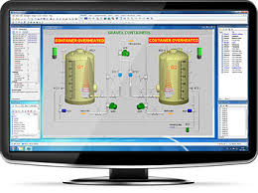  **SCADA & Historian**

**HMI**

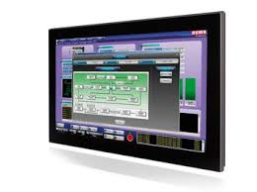 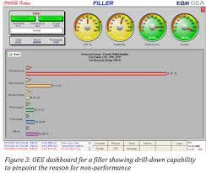 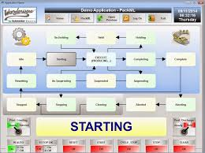 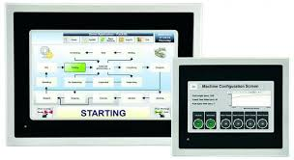

**Standard Machine Interface (OPC DA, Ethernet/IP)**

**Filler Capper Labeller Cartoner Palletizer**

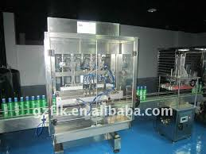 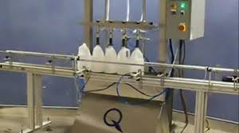 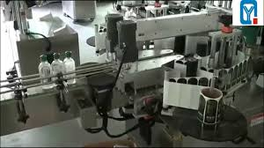 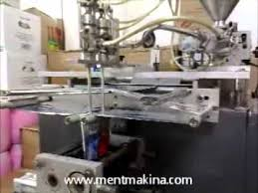 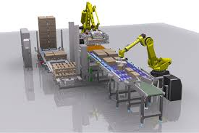

**References:**

<https://en.wikipedia.org/wiki/Packaging_and_labeling>

[http://www.madehow.com/Volume-3/Shampoo.html#ixzz3ib1nYCP1](http://www.madehow.com/Volume-3/Shampoo.html%23ixzz3ib1nYCP1)

http://encyclopedia2.thefreedictionary.com/Packaging+Machine

<https://en.wikipedia.org/wiki/Packaging_machine>

<https://training.gov.au/Training/Details/FDFOP2020A>

http://www.epakmachinery.com/capper-par